The Benefits of Forest Diversity
Creating a healthy forest in North Central Washington
Shane Knowlton; in conjunction with Ethan Tapper, Chittenden County Forester

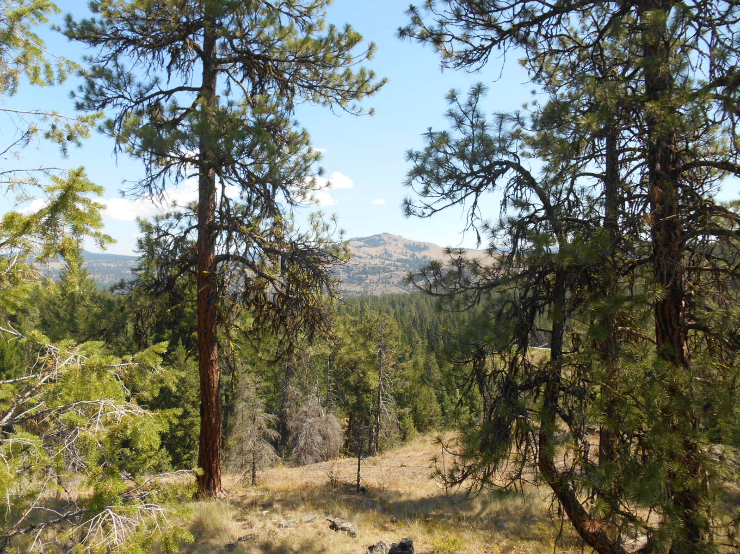

Something that is seldom discussed or encouraged and should be considered whenever there is an opportunity is “diversity” in our forests. Most people want their forests to be healthy and even in some way, want diversity, but they might not know what that actually means or why its important. Contractors, specifically tree saw operators, have the unique ability to create diversity when they are harvesting timber, but they as well, may seldom think about the opportunities they have at their fingertips, to create a diverse forest on each job they operate their machine.
In an ecological context, diversity means several different things. In the forest industry, the term is usually used to describe species diversity. This is the number of different species of trees that exist in the forest. In this sense, a forest with a lot of different species of trees is “very diverse”. From a forest health stand point, this is very important to have a mixed diverse stand to minimize the spread of insects and disease that may be species specific. The more diverse the species, the healthier a forest may be. Other factors of coarse affect forest health, but species diversity is very important.
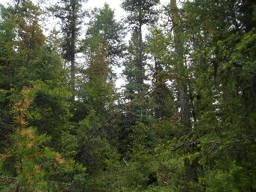
A lesser-known type of diversity is structural diversity, which can be thought of as the way the forest is growing. Structural diversity can be defined as the arrangement of different ages and sizes of trees in a forest; a forest with patches of young trees, old trees and middle-aged trees – and all ages and sizes of trees growing together – is “structural diversity”. This can also be described as a multi-canopied forest. Many individuals that have been in the forest industry for years would call this “tree farming”. When a forest has these characteristics and is managed correctly, a tree farmer can enter a stand of trees every 20+ years and remove a certain volume of timber, while looking at basal area and trees per acre, canopy composition, watching for disease and insect infestation, measuring growth etc. A tree farmer depends on structural diversity because they are managing for multiple generations of trees, always looking to the future.
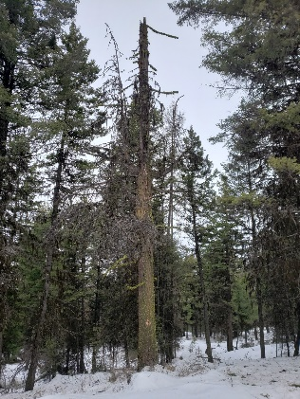
But, “structural diversity” can also refer to the presence or different types of dead trees; dead-standing trees (snags) and dead wood on the forest floor of all different shapes and sizes. While is seems counter-intuitive in todays world of forest management where we are trying to “reduce” as much “fuel” in the forest as possible to minimize the potential for catastrophic stand replacement fires, dead wood in the forest is incredibly important (arguably as important as living trees) for a number if different ecological functions. These range from providing habitat for everything from birds and mammals to the tiny bugs and fungi that make our forests work, to influencing forest hydrology and forming rich soils for future generations of trees.
As land managers, foresters and timber producers, we need to advocate for both species diversity and structural diversity, and not just forests reduced of fuel, or a stand of timber only for producing fiber. Diversity supports everything that we want to manage forests for. Diverse forests provide habitat for a wide range of Washington’s wildlife. Studying old growth forests shows us that species and structural diversity are important parts of how forests naturally grow and develop, which we want to emulate in any management that we do.
We must think about the importance of diversity as a forest having “more tools in its toolkit.” Forests with a lot of species and structural diversity are more resilient – able to remain healthy and productive amidst great stress and change – and adaptive – able to respond differently to the varied forms that disturbance and stressors take. Diversity protects forests from stressors that target a single species of tree – like spruce budworm, mountain pine beetle, ips beetle, Douglas-fir beetle, root disease in Douglas-fir, dwarf mistletoe, etc. These qualities are important to any forest, but are especially crucial in a changing environment, where we see natural disturbances increasing and intensifying with more frequency.
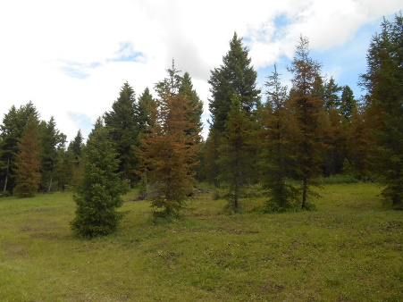
We want to cultivate diversity both within our forests and across the landscape. When managing our forestland, we must go beyond just considering diversity and structural diversity, the sheer number of different species and conditions in the forest, we must also consider “Alpha” diversity. This concept considers “edges” – where forests meet non-forested areas. These areas are some of our most diverse habitats, used by numbers of tree, plant and animal species.
If you managed a forest for maximum Alpha diversity by creating a ton of “edges”, you would help some wildlife species but neglect those that need something different, like wildlife that require large, unbroken forest blocks. You might create great foraging habitat for a species, but nowhere for them to breed, nest or rear their young. You would also be encouraging a habitat type that we may already have in abundance, depending on your location. As our landscape becomes more developed and fragmented, there are plenty of edges and comparatively little unbroken “interior” forest. For these reasons, in addition to Alpha diversity, we should also consider Beta diversity – the “uniqueness” of a site. While a forest or habitat may not support a lot of different species, it might provide something unique – a critical habitat for a few species – and so be worth protecting.
As foresters, contractors, tree saw operators and individual landowners, these concepts may seem non-achievable if an ownership is 20-40 acres. As homeowners / timberland owners, we have no control of landscape level management. Each site however, is unique, and there are little things that can be done to create all the above by understanding that what we do on our plot can add diversity to the whole. During timber harvest, a dense thicket can be retained. If no snags exist, create some by asking the tree saw operator to cut defected trees high leaving snags scattered on the property or girdle disease infected trees creating habitat. Leave small piles of slash for wildlife cover at a rate of 1-2 per 5 acres. Have the skidder operator take “long butts” – long defective parts of the tree that would go into the slash pile – back out onto the property for down woody debris.
Fuels reduction programs, while meant to reduce fuel that could cause a stand replacement fire, can strip a site of diversity if not managed correctly. Mastication equipment grind up all fuels and scatter them on the forest floor which add nutrients quickly back to the soil, but also remove all forage, down woody debris, and structure. During fuels reduction work, thickets of dense trees should be retained to provide cover and habitat as described above for wildlife. If large down logs exist on the property, retain some for habitat for small mammals, invertebrates and insects and site structure.
When species diversity, structural diversity, Alpha diversity and Beta diversity combine, they form complex, resilient and ecologically-functional properties and landscapes. These are properties and landscapes which are beautiful – supporting our quality of life and character of our communities – are functional – providing clean air, clean water, and many other benefits that make our world work – and are productive – producing local renewable resources and other economic and cultural opportunities like forest-based recreation – into the indefinite future.

